**QUESTION:-**

**Write a map reduce program to using a custom counter to count number of people are affected with 'PULMONARY' disease and 'BRONCHITIS & ASTHMA' in the state 'CA'.**

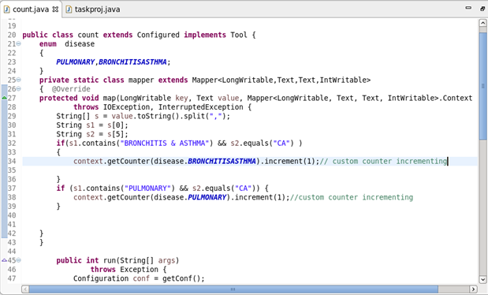

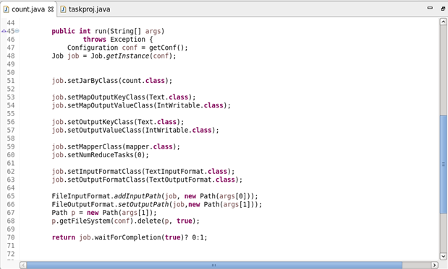

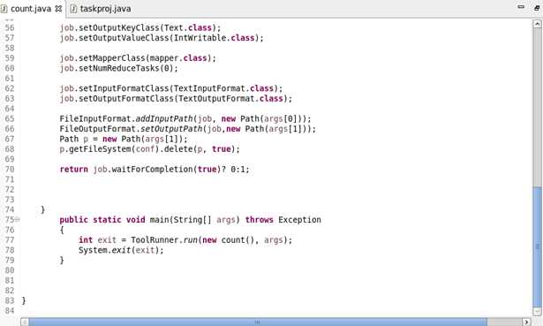

**Output:-**

